Student Name: Yuyang Gong Student Number: 49079984 Team Name: FriendZone
Week: 1
Title: Framing Friendship in a New Environment

Description:
Our project began with a broad question: how might we help people make friends when they enter a new place, life stage, hobby or community? During the first tutorial we mapped experiences around loneliness, unfamiliar environments and the difficulty of approaching people who already appear socially connected.
The discussion showed that the problem was not simply a lack of events. A newcomer may know that activities exist but still feel uncertain about where they belong, how to enter a group and what to say. We therefore started to treat friendship as a gradual process rather than a single matching moment.
Visual Evidence:
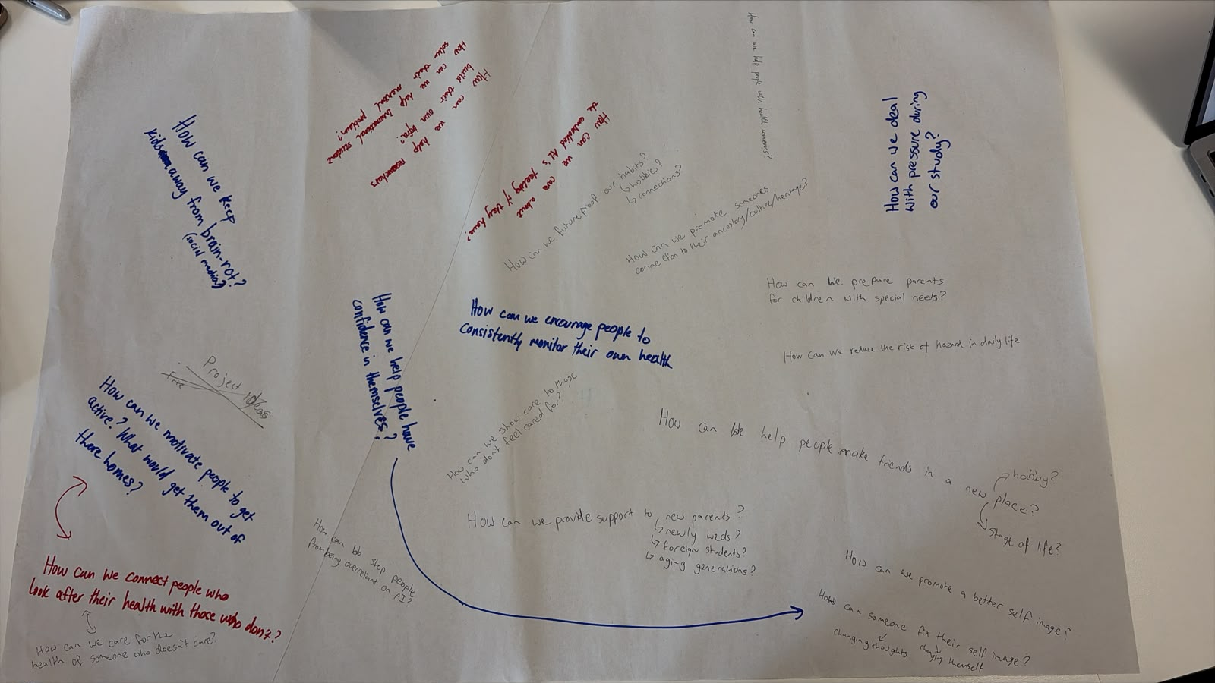
Early tutorial ideation mapping barriers to connection and possible design directions.
Statement on Learning:
I learned that an initial design question can be useful without being a final problem definition. Our first question opened the space, but it was still too broad to guide a distinctive interaction. The most important next step was to gather evidence about the moments where connection breaks down, especially before and immediately after a first meeting.

